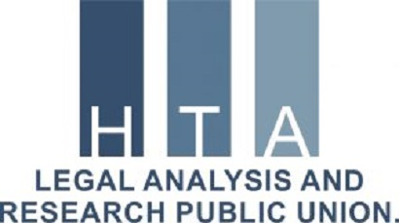

“CIVILIANS ARE UNDER ATTACK!”

The Report

This report covers the factual and legal aspects of the deliberate and indiscriminate attacks on civilians in Azerbaijan, by the Armenian armed forces in Nagorno-Karabakh armed conflict

The report covers the period of 27.09.2020 – 04.11.2020

The report edited by the Chairman of Board
of the “Legal Analysis and Research” Public Union
Mr. Ramil Iskandarli

This report is published with the financial support from the
The Council on State Support to NGOs under the Auspices of the President of the Republic of Azerbaijan

Baku, October, 2020

Content of the report:

- Summary.
- Protection of civilians in international law
- Escalation of the Nagorno Karabakh Conflict
- Some facts that we need to know about the Karabakh conflict
- The total number of civilian casualties

- Aggression by Armenia in 1992-1994
- Attacks on civilians by Armenia
- Massive killings of civilians in Barda (Azerbaijan)
- Ganja (Azerbaijan) massive bombings – acts against humanity
- Violation of humanitarian truce
- Second Violation of humanitarian truce
- Third Violation of humanitarian truce
- Humanitarian help to civilians in Ganja city
- Missile attack on oil pipeline from Armenia
- Azerbaijan strikes only at military facilities
- Protection of women and children in armed conflicts in international law
- Funeral service for 13-year-old Arthur
- Child soldiers in Armenian army
- International legal framework for prohibition using child soldiers
- Paris and Vancouver principles
- Use of the educational facilities for military purposes by Armenia
- International law aspects of the special protection of children
- Mercenaries in Karabakh conflict in Armenian side are the threat to civilians
- Peace enforcement operations (PEOps) by Azerbaijan to protect civilians
- Conclusion and appeal to international community

SUMMARY

91 civilians have been killed, 405 injured and more than 3000 houses and other civilian facilities were seriously damaged as a result of Armenia's heavy artillery attacks on Azerbaijan’s densely populated areas since September 27, the Prosecutor General’s Office has reported.

Protection of civilians in international law

In international humanitarian law, the protection of civilians is not the same as the protection of combatants. This difference is particularly relevant in the conduct of hostilities: there is a fundamental distinction between civilians and combatants, and between military objectives and civilian objects. Combatants may be attacked until they surrender or are otherwise hors de combat, while civilians may not be targeted, unless and for such time as they directly participate in hostilities, and they are protected by the principles of proportionality and precaution against the incidental effects of attacks against military objectives and combatants.

Regarding the legal aspects of the protection of civilians, in accordance with the IV Geneva Convention the protection of civilians during armed conflict is a cornerstone of international humanitarian law. This protection extends to their public and private property. International Humanitarian Law (IHL) also identifies and protects particularly vulnerable civilian groups such as women, children and the displaced persons.

International human rights law and international humanitarian law share the goal of preserving the dignity and humanity of all. Over the years, the UN General Assembly, the Human Rights Council have considered that, in armed conflict, parties to the conflict have legally binding obligations concerning the rights of persons affected by the conflict.

Escalation of the Nagorno-Karabakh Conflict

From September 27, the armed forces of Armenia have launched another act of aggression against Azerbaijan, by intensively attacking the positions of the armed forces of Azerbaijan as well as residential areas along the frontline, with the use of large-caliber weapons, mortar launchers and artillery of different calibers. Having openly and purposefully targeted the civilian population and civilian objects, in addition to military servicemen Armenia has killed a number of civilians, among them elderly, women and children, and inflicted serious damage on numerous houses and civilian objects.
The Armed Forces of the Republic of Azerbaijan operate in the sovereign territories of the Republic of Azerbaijan which recognized by your countries and all international community and organize the defense of Azerbaijan. These are counter-offensive military operations with the aim of enforcing Armenia to peace. The main goal is to ensure the security of the Azerbaijani civilian population living close to the line of contact and to implement counter-offensive peace enforcement operations to prevent such provocations by Armenia.
According to our observations, Armenia is committing war crimes and other violations of the humanitarian law, human rights law, customary law by killing civilians, by using child soldiers, mercenaries and terrorists, and organizing illegal resettlement the ethnic Armenian population from some Middle Eastern countries to Nagorno-Karabakh and adjacent districts, which are internationally recognized territories of Azerbaijan, and using them and local population as a human shield in armed conflict.
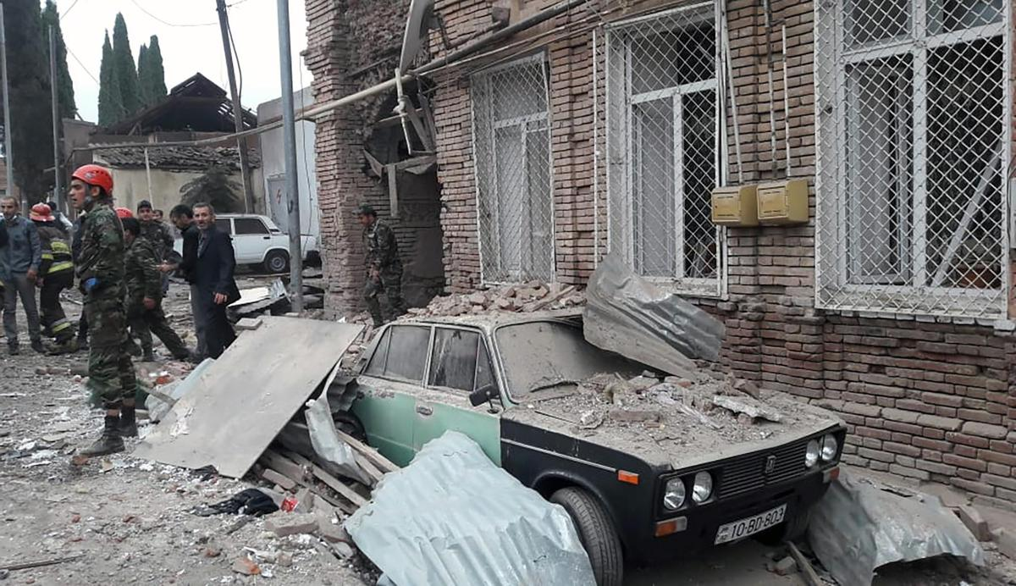

Some facts that we need to know about the Karabakh conflict

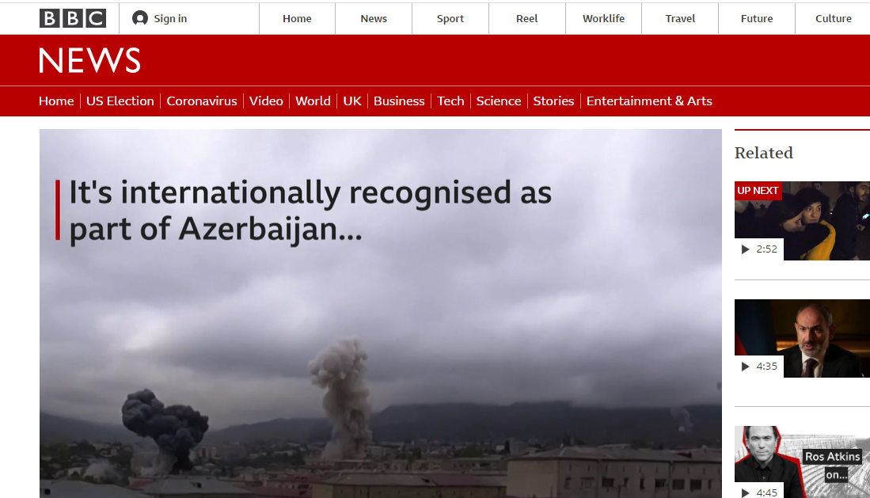
Nagorno-Karabakh is not a "disputed" territory. It is an integral part of sovereign territory of the Republic of Azerbaijan recognized by the UN, other international organizations and states.

Armenia has occupied not only Nagorno Karabakh region, but also 7 adjacent regions - in total more than 20% of the territories of the Republic of Azerbaijan. As a result, nearly one million IDPs - citizens of the Republic of Azerbaijan – ethnically expulled from Nagorno Karabakh and other occupied territories between 1988 and 1994 (during the first Karabakh War). The undergoing war is not on the territories of Armenia. Azerbaijan, currently, is using his right under the UN Resolution Article 51 to prevent aggression against its civil population and to liberate its territories from the occupying forces of the Republic of Armenia. On September 27, 2020, when the current aggressive offensive actions by the Armenian Army started, Azerbaijan responded with counter-offensive military operations. The Azerbaijani Government repeatedly stated, "The Republic of Azerbaijan does not have military targets in the territory of the Republic of Armenia." (Source: AUKAA)

From 27.09.2020 to 04.11.2020, the total number of civilian casualties in Azerbaijan are as the following:
Number of Civilians Killed: 91
Number of Injured Civilians: 405
Number of Houses Fallen into Disrepair: 2734
Number of Residential Buildings Falling into Disrepair: 98
Number of Damaged Civil Facilities: 500 (Source: The Prosecutor General's Office of the Republic of Azerbaijan)

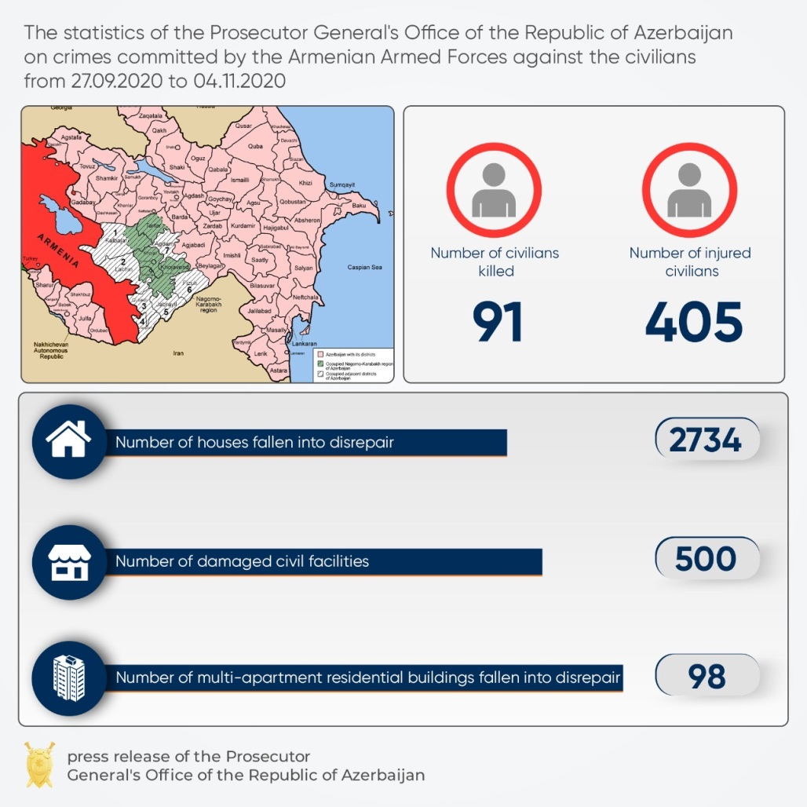
Aggression by Armenia. 1992-1994

Armenia that occupied in 1992-1993 one fifth of the internationally recognized territory of the Republic of Azerbaijan, has been refusing to liberate them despite a clear call for the unconditional withdrawal of the Armenian forces from the occupied territories of Azerbaijan in the UN Security Council resolutions 822, 853, 874, 884 adopted in 1993, as well as Azerbaijan’s good-will and dedication to the peaceful resolution of the conflict. For decades, Azerbaijan struggled with the consequences of unprecedented humanitarian catastrophe which made every 7th person in the country forcefully displaced. Most of our cities under the Armenian occupation turned to ghost cities with totally destroyed and plundered infrastructure.

Armenia has been using acts of genocide as a means to instill fear and to terrorize the entire population and force them to flee. Only in Khojaly massacre 613 civilians of whom 63 were children were brutally killed and many were maimed by the armed forces of Armenia in 1992. One million Azerbaijanis, one thirds of whom are children were forcefully expelled and driven away from their homes, and for almost 15 years the larger part of the forcefully displaced children in Azerbaijan had to live in tent camps and villages consisting of luggage vans on railways which were subsequently abolished as a result of the tremendous efforts and budget resources allocated by the Government of the Republic of Azerbaijan. The internally displaced children in Azerbaijan still cannot realize their right to voluntary return to their lands in safety and dignity. During the conflict, 224 children were taken hostage by Armenia and were subsequently released, and 29 children are still considered to be in Armenian captivity. 73 Azerbaijani children are missing.
Armenia is responsible for total destruction of 1145 educational facilities and 855 kindergartens in the occupied territories of the Republic of Azerbaijan. Tens of thousands of Azerbaijani children continue to realize their right to education under serious challenges stemming from their continued displacement. Many others along the line of confrontation attend their classes under the constant threat of being attacked by the indiscriminate bombing of the armed forces of Armenia.

Attacks on civilians by Armenia

According to the armament index of world countries released by the Bonn International Center for Conversion in February 2020, Armenia ranks third in the world and first in Europe for the number of servicemen per thousand people in Armenia, the cost of armaments in the gross domestic product (GDP), military spending, healthcare, number of troops and the quantity of heavy weaponry. The report says that the reason for Armenia's leading position in the arms race is the Nagorno-Karabakh conflict and its militaristic policy over the past 30 years.
(Source: Armament index, Bonn International Center for Conversion in February 2020).
In an interview with TV show "Vesti" aired on the Russian TV channel Russia-1 on 8 October, Vagharshak Harutyunyan, the chief adviser to Prime Minister Nikol Pashinyan, openly stated that Armenia is purposefully bombarding peaceful cities of Azerbaijan and targeting civilians to create panic among them. (Source: Caspian News, https://caspiannews.com/news-detail/pashinyans-advisor-confirms-armenias-deliberate-attacks-on-azerbaijani-civilian-settlements-2020-10-9-0/)
Since the deadly clashes between Armenia and Azerbaijan broke out on September 27, Armenia's forces have continued to shell densely populated areas, strategically important civilian and energy infrastructure, which are far from the frontline. The skirmishes broke out after Armenia's forces deployed in the occupied Azerbaijani lands hit Azerbaijani civilian settlements and military positions along the front zone in the occupied Nagorno-Karabakh region of Azerbaijan.
Armenia's forces have so far launched intensive missile attacks against Azerbaijan’s second-largest city of Ganja, which is more than 60 kilometers away from the conflict zone, the central Azerbaijani city of Mingachevir, which hosts the country's largest hydroelectric power and water reservoir, as well as Barda, Tartar and Beylagan. They also hit the Khizi-Absheron region near Azerbaijan’s capital Baku with mid-range missiles.
Russian military expert Igor Korotchenko expressed confidence that by shelling Azerbaijani cities, Yerevan is trying to provoke Baku into tit-for-tat response. If Yerevan can demonstrate that military activities are taking place not only in the territory of the occupied Nagorno-Karabakh region of Azerbaijan, but also in Armenia itself, then it can demand military support from Russia.

Pashinyan's tactics: To make an attack on Azerbaijani cities, provoke Baku to retaliate against targets in Armenia, and then seek for help from Russia and the CSTO acting as "a victim of aggression," Korotchenko said, commenting on the Armenia's attacks on residential areas of Azerbaijan, according to Armiya.az citing APA.

Emboldened by the 30 years impunity for its war crimes and crimes against humanity, Armenia has started another aggression against the Republic of Azerbaijan since September 27, 2020. Armenia continues shelling Azerbaijan’s densely populated areas using heavy artillery.
65 civilians have been killed and 297 others have been injured since the outbreak of large-scale hostilities on September 27, after Armenia launched another attack along the line of contact, the Prosecutor General’s Office has reported.
Among the civilians are ten children.
As a result of the shelling of civilian infrastructure facilities by the occupying country's armed forces, 2,243 houses and 90 multi-apartment residential buildings, as well as 402 civilian facilities were severely damaged.
Vehicles belonging to civilians became unserviceable, and numerous small and large horned animals and haystacks were destroyed as well.
Moreover, as a consequence of rocket and heavy artillery attacks on October 4, 11 and 17, a total of 25 civilians were killed and 139 were injured in Ganja city. The city's civil infrastructure facilities and vehicles were inflicted extensive damage.

Mass killings of civilians in Barda

As of morning of October 28, as a result of the shelling of civilian infrastructure facilities by the occupying country's armed forces, 2,338 houses and 92 multi-apartment residential buildings, as well as 415 civilian facilities were severely damaged.
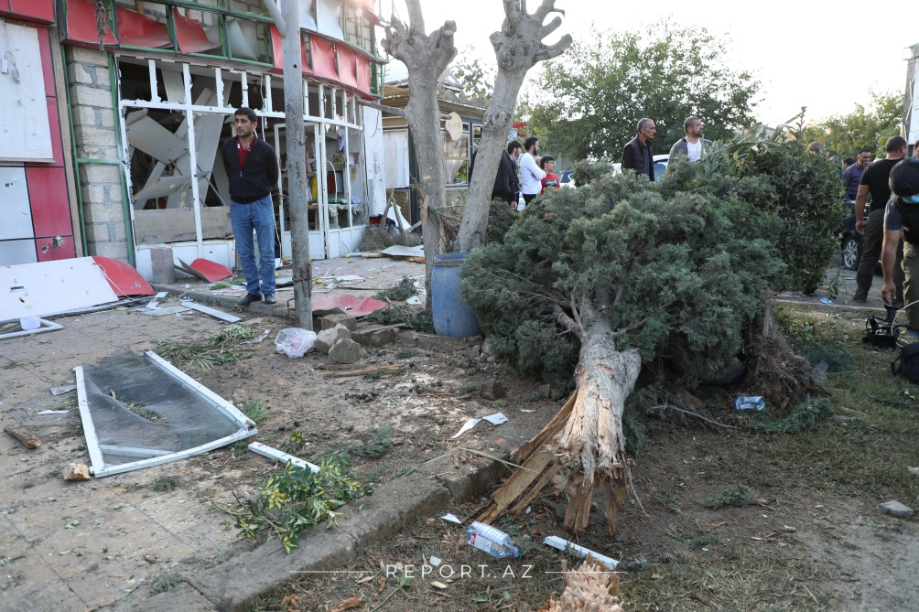
Vehicles belonging to civilians became unserviceable, and numerous small and large horned animals and haystacks were destroyed as well.
On October 27, Armenia launched a missile attack at Barda region, as a result of which 5 civilians, including child, were killed and 13 civilians, including women and children, seriously wounded. In addition, on October 28, Armenian launched another missile attack at Barda region, as a result of which 21 civilians were killed and about 70 wounded.
The missile attack on civilian population came after US-mediated cease-fire agreement that was announced on October 25. Thus, Armenia grossly violated the humanitarian ceasefire already for third time.
Moreover, as of October 23, as a consequence of rocket and heavy artillery attacks on October 4,11 and 17, a total of 25 civilians were killed and 139 were injured in Ganja city. The city's civil infrastructure facilities and vehicles were inflicted extensive damage.
Furthermore, 7 civilians were killed and 10 were injured in Goranboy region. On September 27, as a result of shrapnel hitting the yard of a private house in Naftalan region, all members of one family (5 civilians) were killed.
Likewise, 16 civilians were killed and 50 were injured in Tartar region, 6 civilians were killed and 25 were injured in Barda region, 2 civilians were killed and 2 were injured in Beylagan region, one civilian was killed and 19 were injured in Aghjabadi region, 3 civilians were killed and 17 were injured in Fuzuli region, 7 civilians were killed and 40 were injured in Aghdam region and 5 civilians were injured in Mingachevir region. In addition, in Dasheksan, Jabrayil, Khojali and Gabala regions one civilian was injured in each.
Amnesty International has verified the use of banned cluster bombs by Armenia, following an attack on the city of Barda in Azerbaijan, media reported quoting the statement released by Amnesty International.The statement says, at approximately 1.30pm local time, one or several Smerch rockets were fired into Barda, striking a residential neighbourhood close to a hospital. The Azerbaijani Prosecutor General’s Office has stated that at least 21 people were killed, with an estimated 70 more injured.Amnesty International’s Crisis Response experts verified pictures (taken by Vice News reporters in the city) of fragments of 9N235 cluster munitions from Russian-made 9M55 Smerch rockets, that appear to have been fired into the city by Armenian forces.
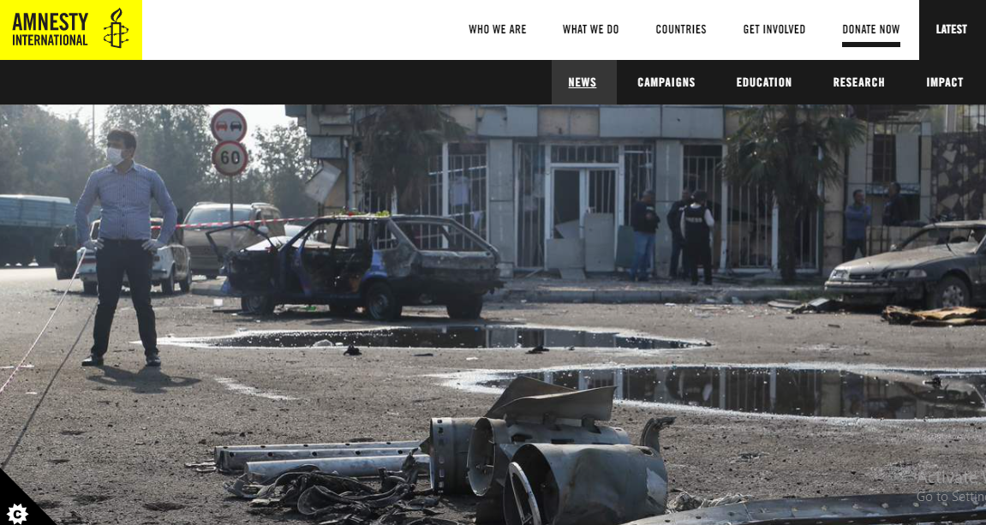
“The firing of cluster munitions into civilian areas is cruel and reckless, and causes untold death, injury and misery." The organization noted that use of cluster munitions in any circumstances is banned under international humanitarian law.
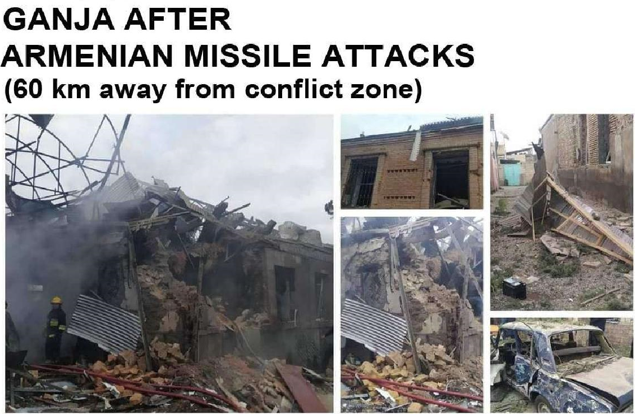

Furthermore, 7 civilians were killed and 10 were injured in Goranboy region. On September 27, as a result of shrapnel hitting the yard of a private house in Naftalan region, all members of one family (5 civilians) were killed.
Likewise, 16 civilians were killed and 50 were injured in Tartar region, 25 civilians were killed and around 70 were injured in Barda region, 2 civilians were killed and 2 were injured in Beylagan region, one civilian was killed and 19 were injured in Aghjabadi region, 3 civilians were killed and 17 were injured in Fuzuli region, 7 civilians were killed and 40 were injured in Aghdam region and 5 civilians were injured in Mingachevir region. In addition, in Dasheksan, Jabrayil, Khojali and Gabala regions one civilian was injured in each.
Armenian armed forces launched a large-scale operation in the front-line zone on September 27 at 6 am, shelling the positions of the Azerbaijani army from large-calibre weapons, mortars, and artillery installations of various calibres. Armenia has been targeting Azerbaijan’s densely populated areas and infrastructure projects.

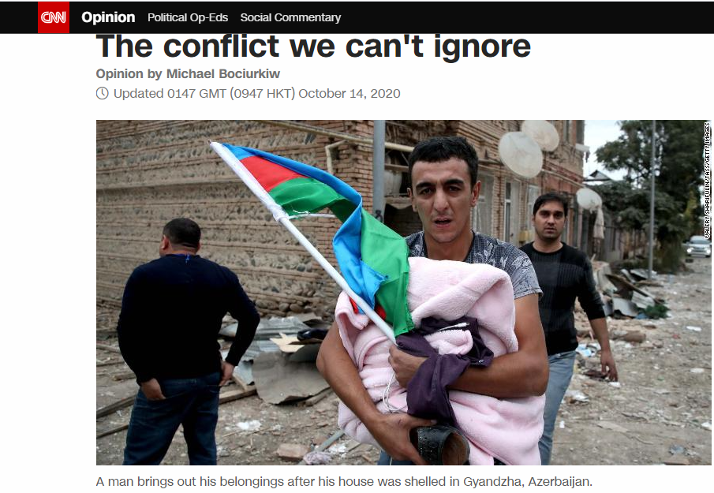

Ganja massive bombings – acts against humanity
Article 18 of the 1949 “Geneva Convention for the Protection of Civilian Persons in Time of War” states that under no circumstances should the parties to a conflict throw shells or artillery at civilian gatherings. The military-political leadership of the aggressor state of Armenia continues to target civilians, houses, civilian sites and settlements, and commit crimes against civilians in violation of all international norms and principles, in gross violation of its obligations under the Geneva Conventions. Population centers, district and village centers, civil infrastructure facilities, hospitals, medical centers, school buildings and kindergartens are targeted deliberately.

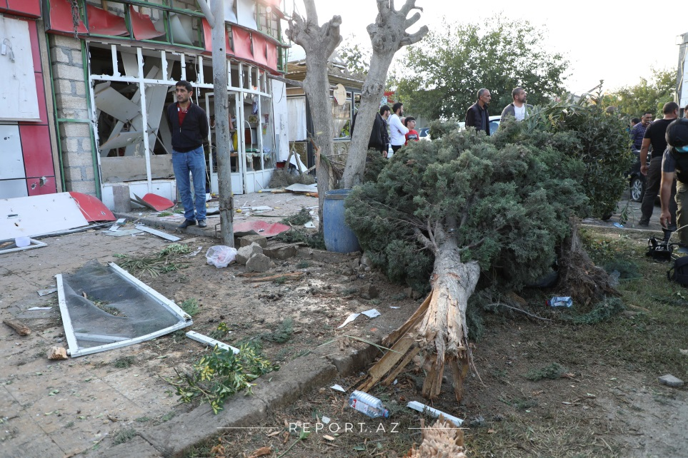
Despite the agreement reached on ceasefire on October 10, 2020, Armenia once again demonstrated stubborn negligence of its obligations and spitefully attacked on the night of October 11, the second biggest city in Azerbaijan, Ganja situated far beyond the frontline. 10 civilians were killed and 34, including minors, were seriously injured. As a result of rocket fire on residential buildings 3 children lost their both parents. This nefarious attack was repeated on the night of October 17, taking the life of 13 civilians, including 3 minors, and injuring 48 civilians, including 5 children. Two children are missing in Ganja.

Violation of humanitarian truce
According to the Article 15 of the Convention (I) for the Amelioration of the Condition of the Wounded and Sick in Armed Forces in the Field. Geneva, 12 August 1949, at all times, and particularly after an engagement, Parties to the conflict shall, without delay, take all possible measures to search for and collect the wounded and sick, to protect them against pillage and ill-treatment, to ensure their adequate care, and to search for the dead and prevent their being despoiled.
Whenever circumstances permit, an armistice or a suspension of fire shall be arranged, or local arrangements made, to permit the removal, exchange and transport of the wounded left on the battlefield.
Likewise, local arrangements may be concluded between Parties to the conflict for the removal or exchange of wounded and sick from a besieged or encircled area, and for the passage of medical and religious personnel and equipment on their way to that area.
Armenia violated such humanitarian truce agreements there times in a row. As known, a trilateral meeting of the Foreign Minister of the Russian Federation Sergei Lavrov, the Foreign Minister of Azerbaijan Jeyhun Bayramov and the Foreign Minister of Armenia Zohrab Mnatsakanyan was held in Moscow on October 9, 2020 on the initiative of Russian President Vladimir Putin to declare a humanitarian ceasefire," the appeal said.
"After a meeting that lasted about 11 hours, an agreement was reached consisting of following 4 points:
1. To declare a ceasefire for humanitarian purposes starting from 12 p.m. on October 10 for the exchange of the prisoners of war, other people detained and bodies of those killed, with the mediation and in accordance with the criteria of the International Committee of the Red Cross;
2. Further parameters of the ceasefire will be agreed upon additionally;
3. The Republic of Armenia and the Republic of Azerbaijan, with the mediation of the OSCE Minsk Group Co-Chairs, on the basis of the fundamental principles of the settlement, are launching substantive negotiations with the aim of achieving early peaceful resolution;
4. The sides reiterate the inalterability of the format of the peace process," the appeal said.
However, unfortunately, the Armenian side, in violation of all the provisions of the agreement signed, in accordance with its hypocritical and aggressive nature, continues to subject the frontline regions and villages, as well as the cities of Azerbaijan situated far away from the conflict zone, to heavy artillery and missile fire, grossly violating the ceasefire agreement.
The most regrettable is that on October 11, at around 4 AM, the second largest city of Azerbaijan, Ganja, with a population of more than 500,000 people, located 80 km from the frontline, was shelled by the order of the political-military leadership of Armenia. As a result of this barbaric and atrocious attack of Armenia, 3 residential buildings were destroyed, more than 9 civilians, including 4 women, were killed and 34 were wounded, including 16 women and 6 children.

Second violation of humanitarian truce, 17 October 2020

In October 17, Armenia once again attacked Ganja, the second largest city of Azerbaijan, firing a SCUD / Elbrus ballistic missile on the densely populated block of the city, killing 13 people and injuring more than 40. Among the dead and injured were the children, women and the elderly people.
This was the third time in the last two weeks that the city of Ganja has come under heavy rocket fire of Armenia, and so far 27 civilians have been killed and more than 100 injured.
The bombing of the Ganja, the city with a population of more than 500,000 people situated far from the conflict zone, without any military necessity by the Armenian political-military leadership, the deliberate and indiscriminate use of powerful destructive missiles such as SCUDs to kill innocent civilians will be included in the history books as the bloodiest war crime committed against humanity in the XXI century.
It is not only this act of savagery, barbarism and terrorism committed by Armenia in the eyes of the whole world that worries and deeply concerns the Azerbaijani public, it is also seriously infuriated and disturbed by the silence about the human tragedy, genocide and war crimes committed in Ganja of the UN Security Council, which must stop and punish the aggressors around theglobe and was established for this purpose by the world community.

Third violation of the humanitarian truce by Armenia (October 26, 2020)

Azerbaijan Foreign Ministry issued statement, saying that Armenia has blatantly ignored and violated the ceasefire regime with Azerbaijan for a third time in a row. “In a gross violation of the new humanitarian ceasefire, on October 26, Armenian armed forces subjected to artillery fire the units of Azerbaijani Army located in the Lachin’s region Safiyan village. Later, the Tartar city and villages of the region were under intensive shelling by the Armenian armed forces,” the ministry stated.
As reported on October 28th, at around 1 pm, again, after first attack, the hostile armed forces using cluster bombs prohibited by international law launched missile attacks massively for the second at densely populated areas of Barda district, where trade facilities are located. As a result, 21 civilians were killed and up to 70 wounded. Civil infrastructure facilities and vehicles were extensively damaged.
Thus, it was underlined that Armenia grossly violates all the humanitarian ceasefire reached - first on October 10 Moscow joint statement, then on October 18 reaffirmed commitments by the mediation efforts of Paris and now on October 24 after meeting in Washington and agreeing on implementing the immediate humanitarian ceasefire.
It was noted that this is another demonstration of willful ignorance by Armenia of its commitments and open disrespect to the tireless endeavors of international mediators.

Humanitarian help to civilians in Ganja city

Along with the Azerbaijani government, other friendly countries, such as Israel has sent humanitarian and medical aid to the residents of Ganja, the second largest city of Azerbaijan, which came under missile attacks by Armenia, the Israeli Yedioth Ahronoth newspaper said, Trend reported citing TASS.
According to the newspaper, Israel, as a humanitarian and medical aid for dozens of civilians who suffered from the shelling in Ganja city, supplied heaters, warm clothes, blankets, first aid kits, and basic necessities. The second batch of Israeli aid with consumables for medical supplies was delivered to Ganja on October 24, noting that "Israel is ready to supply medical equipment if necessary". On October 23, Ambassador of Israel to Azerbaijan George Dick visited Ganja, Yedioth Ahronoth newspaper added.
"I came [to Ganja] to express my condolences and the condolences of the State of Israel to the victims and wish a speedy recovery to the wounded," the ambassador said upon his arrival. "I met some of the victims and I will meet more later, their stories are heartbreaking. As Israelis, we know the destructive effect of war, especially when innocent civilians are under attack. Violence against civilians, no matter what nationality or religion, is unacceptable. No one should lose loved ones, friends or neighbors while they sleep peacefully at night."
(Yedioth Ahronoth, 25.10.2020, YNEhttps://www.ynetnews.com/article/Sk11bDGm00P)

“During my visit yesterday to Ganja, I saw at firsthand the situation of children. I was saddened to hear the reports that more children had been injured over the weekend and extend my condolences to those affected.
Media reported that UNICEF Representative to Azerbaijan Edward Carwardine stated this. Edward Carwardine noted that UNICEF repeats its urgent call for the protection of civilians and civilian infrastructure, and reiterates that a cessation of hostilities is in the best interest of all children: "I spoke in Ganja with Mr Hikmat Hajiyev, Assistant to the President, to offer UNICEF’s support for children and families, particularly in responding to psychological trauma and keeping children safe from unexploded ordnance, and we agreed to implement this assistance urgently." (https://en.axar.az/news/society/506910.html).

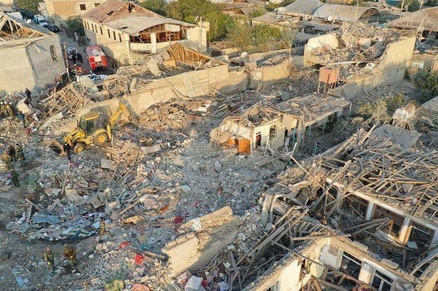

Missile attack on oil pipeline from Armenia
Azerbaijan is a developing country and it is a big hub for multi-billions of investments. Azerbaijan also plays an important role in Europe's energy security through several significant energy projects such as Baku-Tbilisi-Ceyhan (BTC) oil pipeline, the Trans Adriatic Pipeline (TAP) and the Trans Anatolian Natural Gas Pipeline (TANAP). Not surprisingly, as a part of their terror policy, Armenian forces launched a missile attack on last Tuesday on the BTC oil pipeline amid the conflict, that was successfully prevented by the Azerbaijani army, on the part of pipeline in Yevlah city. Azerbaijan described the attack as a "terrorist act" and highlighted the pipeline's important role in Europe's energy security.
Armenia has shelled Azerbaijani power plants and pipelines of strategic importance, which threatens not only the security of Azerbaijan, but also the region, Azerbaijani Energy Minister Parviz Shahbazov said in October 28, 2020.
Shahbazov made the remark at the Baku International Energy Charter Forum on "Transition to renewable energy sources in electricity production, transport, heating and cooling: modern challenges and trends,", Trend reports.
"The Armenian side continues to shell the peaceful cities of our country. We have already faced Armenian aggression. Since the beginning of hostilities, Armenia has repeatedly struck the strategic pipeline, which is part of the Southern Gas Corridor," the minister said.
These are just few evidences of the ongoing Armenian aggression towards Azerbaijan and its territorial integrity. This aggression can escalate to its highest point in any time, putting whole population and infrastructure of the country in danger. Simultaneously, Armenia's policy of terrorism threatens security and stability not only of Azerbaijan but also the whole region, as well as the business and investment climate too.
American Chamber of Commerce in Azerbaijan (AmCham Azerbaijan) issued a statement supporting territorial integrity of Azerbaijan. According to the statement, AmCham Azerbaijan is deeply concerned with the events developing in the Nagorno-Karabakh region and other areas of Azerbaijan. The Chamber strongly condemns all attacks on Azerbaijan, especially recent large-scale shelling of civilian population and strategic infrastructure facilities carried out from the territory of Armenia.
AmCham Azerbaijan unequivocally supports the territorial integrity of Azerbaijan and calls for the resolution of the conflict within the framework of international law and in line with the UN Security Council Resolutions 822, 853, 874 and 884 which demand immediate, complete and unconditional withdrawal of all the occupying forces from the occupied territories of the Republic of Azerbaijan.
In the statement it was also emphasized that, the liberation of several occupied territories in the past days from the Armenian occupation gives hope, first time in 30 years, for more than one million of Azerbaijani refugees and internally displaced persons to return to their homes and sustainable peace and stability in the region.
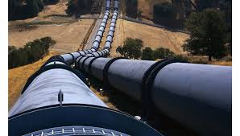

(Rashid Mammadov, The London Watch Legal E-Digest , October 11, 2020
http://thelondonwatch.com/2020/10/11/rashid-mammadov-american-chamber-of-commerce-in-azerbaijan-issued-a-statement-supporting-territorial-integrity-of-azerbaijan/)

Azerbaijan strikes only at military facilities
Azerbaijan strikes only at military facilities stationed by the Armenian armed forces in the occupied territories, all possible precautionary measures in accordance with the convention have been taken in order not to damage the civilians and civilian facilities.
At present, Azerbaijan is exercising the right to self-defense enshrined in Article 51 of the UN Charter within the framework of these resolutions, as well as the use peace enforcement operations provided for in Chapter VII of the UN Charter.
In order to prevent Armenian military aggression and ensure protection of the civil population, the Azerbaijani Army took counter-attack measures to repel the assault.
According to the Artilce 51 of UN Charter, nothing in the present Charter shall impair the inherent right of individual or collective self-defence if an armed attack occurs against a Member of the United Nations. Measures taken by Members in the exercise of this right of self-defence shall be immediately reported to the Security Council and shall not in any way affect the authority and responsibility of the Security Council under the present Charter to take at any time such action as it deems necessary in order to maintain or restore international peace and security.”
In accordance with the provisions of Chapter VII of the UN Charter, as a rule, with the use of elements of coercive action, in order to prevent aggression or threats to international peace and security by any state, or by the parties to the conflict or the state in conflict. These are peace enforcement operations carried out by the without the consent of the international community. These operations can be carried out only on the basis of a UN Security Council resolution. As we know, 4 UN Security Council resolutions have been adopted on the settlement of the Nagorno-Karabakh conflict.
The resolutions noted that stability and peace in the region were under threat, expressed concern over the growing number of IDPs and stressed the need to address the problems caused by the state of emergency in the occupied territories. The UN Security Council called for an end to the occupation in order to achieve a permanent ceasefire and the withdrawal of the Armenian forces from the occupied territories of Azerbaijan. According to the Paragraph 138 of the Resolution on the Outcomes of the World Summit, adopted by the UN General Assembly on 16 September 2005, at the World Summit of the Heads of State and Government, have gathered at United Nations Headquarters in New York from 14 to 16 September 2005, the Heads of States reaffirmed that each individual State has the responsibility to protect its populations from genocide, war crimes, ethnic cleansing and crimes against humanity. This responsibility entails the prevention of such crimes, including their incitement, through appropriate and necessary means. Azerbaijan is acting in accordance with it. The international community should, as appropriate, encourage and help States to exercise this responsibility. The international community, through the United Nations, also has the responsibility to use appropriate diplomatic, humanitarian and other peaceful means, in accordance with Chapters VI and VIII of the UN Charter, to help to protect populations from genocide, war crimes, ethnic cleansing and crimes against humanity.

Protection of women and children in armed conflicts in international law

If we talk about specific protection of children and women, international humanitarian law provides general protection for children and women as persons taking no part in hostilities, and special protection as persons who are particularly vulnerable.
Protocol II of 1977 also codifies the principles according to which the civilian population as such, as well as individual civilians, shall not be the object of attack. The Fourth Geneva Convention comprises a great many provisions in favour of children. They show that, already in 1949, it was felt that children should be especially protected against warfare.
Armenia is violated the principles stipulated by the Declaration on the Protection of Women and Children in Emergency and Armed Conflict and which calls for the strict observance of the Declaration by all Member States. Attacks and bombings on the civilian population, inflicting incalculable suffering, especially on women and children, who are the most vulnerable members of the population, shall be prohibited, and such acts shall be condemned.
The Declaration on the Protection of Women and Children in Emergency and Armed Conflict calls for the strict observance of the Declaration by all Member States:
1. Attacks and bombings on the civilian population, inflicting incalculable suffering, especially on women and children, who are the most vulnerable members of the population, shall be prohibited, and such acts shall be condemned.
2. The use of chemical and bacteriological weapons in the course of military operations constitutes one of the most flagrant violations of the Geneva Protocol of 1925, the Geneva Conventions of 1949 and the principles of international humanitarian law and inflicts heavy losses on civilian populations, including defenceless women and children, and shall be severely condemned.
3. All States shall abide fully by their obligations under the Geneva Protocol of 1925 and the Geneva Conventions of 1949, as well as other instruments of international law relative to respect for human rights in armed conflicts, which offer important guarantees for the protection of women and children.
4. All efforts shall be made by States involved in armed conflicts, military operations in foreign territories or military operations in territories still under colonial domination to spare women and children from the ravages of war. All the necessary steps shall be taken to ensure the prohibition of measures such as persecution, torture, punitive measures, degrading treatment and violence, particularly against that part of the civilian population that consists of women and children.
5. All forms of repression and cruel and inhuman treatment of women and children, including imprisonment, torture, shooting, mass arrests, collective punishment, destruction of dwellings and forcible eviction, committed by belligerents in the course of military operations or in occupied territories shall be considered criminal.
6. Women and children belonging to the civilian population and finding themselves in circumstances of emergency and armed conflict in the struggle for peace, self-determination, national liberation and independence, or who live in occupied territories, shall not be deprived of shelter, food, medical aid or other inalienable rights, in accordance with the provisions of the Universal Declaration of Human Rights, the International Covenant on Civil and Political Rights, the International Covenant on Economic, Social and Cultural Rights, the Declaration of the Rights of the Child or other instruments of international law.

Unfortunately, this does not mean that the international community will react immediately to Armenia's actions. We have been witnesses for many times, that international community were closed their eyes to unlawful actions of Armenia in regards to Azerbaijan. The only right way in such a situation is to continue the peace enforcement operations of the Azerbaijani army to force Armenia to withdraw the occupying forces from the territories of Azerbaijan as required by the UN Security Council 4 resolutions on Karabakh.

During 30 years of conflict, Armenia has not stop to surprise the international community by the level of its barbarism and cruelty. Attacking innocent children sleeping at night in the cities that do not contain any military objects is an immoral practice of conducting war invented by Armenia. Our hearts are bleeding when we look at 3 years old Khadija lying on a hospital bed, and who lost her both parents and one year old sister. This is not the way that innocent children should be behaved.
The internally displaced children in Azerbaijan still cannot realize their right to voluntary return to their lands in safety and dignity. During the conflict, 224 children were taken hostage by Armenia and were subsequently released, and 29 children are still considered to be in Armenian captivity. 73 Azerbaijani children are missing.

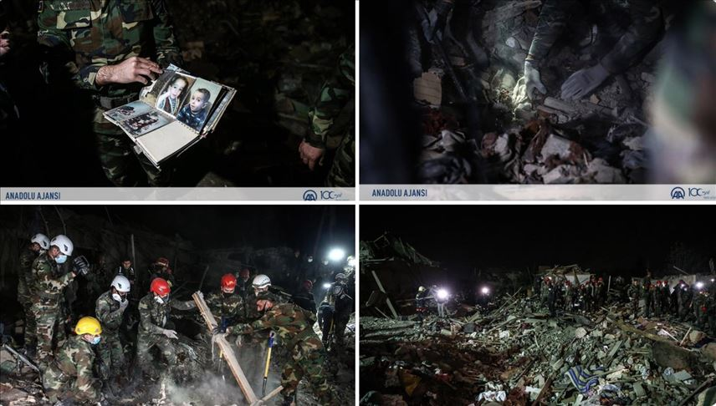

Children in Azerbaijan are the targets by Armenian aggressors even during the ceasefire time. During the ceasefire since 1994, 34 children became victims of the Armenian terror, 14 of them were killed and 20 were injured. Another murder that got away with Armenian extremists happened in 2017, when the Armenian Armed Forces fired from 82- and 120-mm mortars and heavy grenade launchers at the village of Alkhanly, Fizuli region, as a result of which 18-month-old girl Zakhra Guliyeva and her 50-year-old grandmother Sahiba Guliyev died. This murder shook the whole world, by showing the Armenia's true colors, however, the Armenians still got away with it due to the world community's unresponsiveness! In total, over the years, about 350 thousand innocent children have suffered from an unjust war.
Over the years of the conflict, Armenian armed groups have purposefully targeted civilians and civilian facilities of Azerbaijan, including schools, hospitals, and administrative buildings.
The Presidential aide Hikmat Hajiyev noted that the Armenian armed forces once again fired missiles from Armenia’s territory on residential settlements in the direction of Azerbaijan’s Fuzuli and Jabrayil districts, which resulted in fatalities and injuries among civilians. “During the recent days, over 10,000 pieces of projectiles and missiles of various types were launched on Azerbaijan’s densely populated settlements. Over 500 private houses were completely destructed or seriously damaged.
Azerbaijani Prosecutor General Kamran Aliyev has made a statement on the Armenian armed forces’ shelling of the city of Ganja: “October 4, 2020, at about 10 am, Ganja, the second largest city of the Republic of Azerbaijan, with a population of more than five hundred thousand civilians, was subjected to rocket and artillery shelling which is a blatant violation of the requirements of the Geneva Conventions.

Funeral service for 13-year-old Arthur

A funeral service for 13-year-old Artur Mayakov, who died due to the Armenian terror, is being held at the Russian Orthodox Church in Azerbaijan’s Ganja city, Trend reports.
The leadership of the Mayor’s Office of Ganja city, representatives of the Russian community, and other residents of the city are taking part in the farewell ceremony.
Russian citizen Artur Mayakov, who was wounded due to Armenia's missile strike on Ganja on Oct. 17, died on Oct. 24.

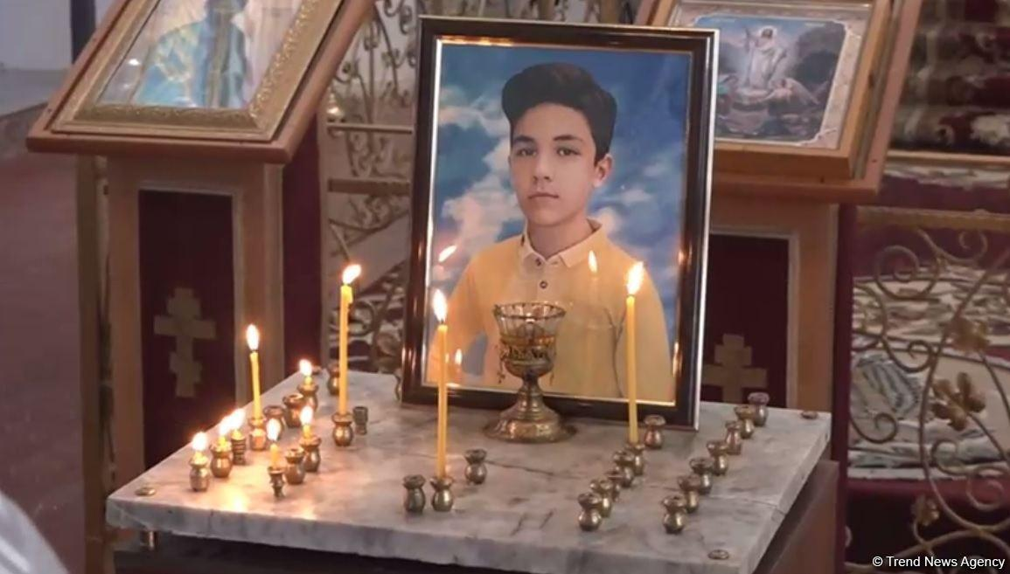

Child soldiers in Armenian army

"Video shows that Armenia employs child-soldiers. Needs to be investigated", Assistant of the President of the Republic of Azerbaijan, Head of Foreign Policy Affairs Department of the Presidential Administration Hikmet Hajiyev wrote on his Twitter page. He also added that, "Recruiting and using children under the age of 15 as a soldier is prohibited under international humanitarian law – treaty and customs – and is defined as a war crime by ICC".
It is not the first time, Armenia commits a war crimes in relation to children. According to the “Child Soldiers Report 2001- Armenia”, “Recruitment of children has been reported to occur in practice. The Committee on the Rights of the Child, at its January 2000 session, raised questions regarding reports of refugee children from Azerbaijan being forced to join the Armenian army. The delegation responded that Armenian children in Nagorno-Karabakh had been known to take up arms against Azerbaijan "in defence of their territory". The Committee recommended that Armenia should refrain from conscripting children into the armed forces and should take special protection and rehabilitation measures for children affected by armed conflict” (see the UN press release, UN CRC concluding observations on the status of children's rights in Armenia, 20/1/00, HR/CRC/00/15 and also UN document reference CRC7C794).
Absolutely no actions have been taken by Armenia in regard to the recommendations of the report. Furthermore, they keep repeating to commit this war crime. Now, in 2020, again in Karabakh armed conflict.

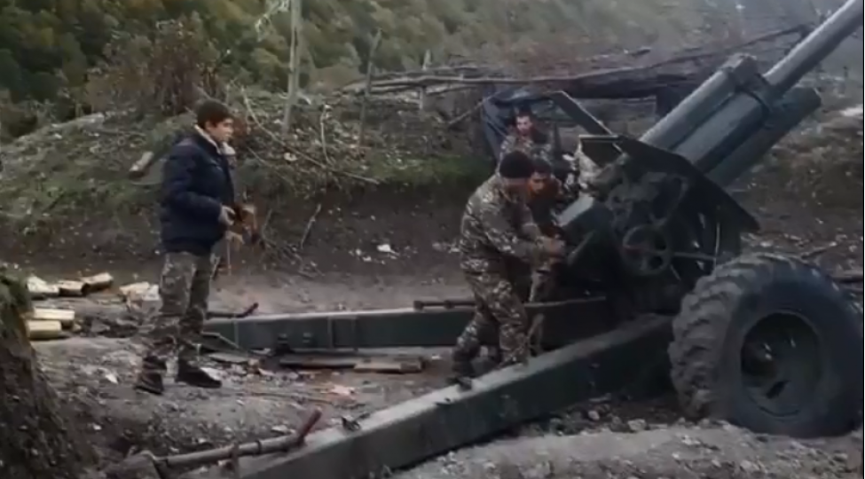

International legal framework for prohibition using child soldiers

UN Secretary General in its report titled “Children and Armed Conflict” at the 74th session in June 2020, called upon Member States to respect the rights of the child, including through accession to the Optional Protocol to the Convention on the Rights of the Child on the involvement of children in armed conflict, and the endorsement and implementation of the Paris Principles and Vancouver Principles on Peacekeeping and the Prevention of the Recruitment and Use of Child Soldiers.
International Humanitarian Law prohibits the recruitment and use of children in hostilities. The article 50 of the IV Geneva Convention, stated that, an Occupying Power must not enlist children on the occupied territory (GC IV, Art. 50). This provision is understood to relate only to children below the age of 15 years.
The prohibition is applicable in both international and non-international armed conflicts (such as a current Karabakh armed conflict, between Armenia and Azerbaijan). The bans on recruitment of children below the age of 15 enshrined in Article 77 of Additional Protocol I, and in Article 4 of Additional Protocol II to the Geneva Conventions of 1949 are also considered to prohibit accepting voluntary enlistment (P I, Art. 77 (2); P II, Art. 4(3)(c)).
Article 77 states that, the Parties to the conflict shall take all feasible measures in order that children who have not attained the age of fifteen years do not take a direct part in hostilities and, in particular, they shall refrain from recruiting them into their armed forces. Paragraph 3 of the Article 4, of Additional Protocol II is devoted more particularly to the protection of children and reiterates some principles contained in the fourth Convention. Provisions of the protocol includes protection from the effects of hostilities (sanitary zones, evacuation), provision of special care and aid (medicine, food, clothing), protection of personal status, family and community ties (identity, registration, reunification, news), cultural environment, education, or limits to the death penalty. Other provisions specifically regulate the treatment of detained or interned children.

Children are protected also by general human rights instruments. In addition, they are entitled to the protection provided by the Convention on the Rights of the Child (CRC), which has been ratified by all states in the world, apart from Somalia and the United States of America. Article 38(3) of the Convention on the Rights of the Child prohibiting the recruitment of children below the age of 15 is similarly interpreted as banning voluntary enlistment of such children and, hence, completely outlawing child soldiers.
The Optional Protocol to the Convention on the Rights of the Child differentiates between States and non-State armed groups in setting the age-limit for recruitment and use in hostilities. Armed groups that are distinct from the armed forces of a State should not, under any circumstances, recruit or use in hostilities persons under the age of 18 years.
States Parties shall take all feasible measures to prevent such recruitment and use, including the adoption of legal measures necessary to prohibit and criminalize such practices.
Under the Statute of the International Criminal Court, conscripting or enlisting children into armed forces or groups constitutes a war crime in both international and non-international armed conflicts (ICC Statute, Article 8(2)(b)(xxvi) and (e)(vii)).

Paris and Vancouver principles

Another important documents in the sphere of protection of child soldiers are the Paris Principles and the Vancouver Principles.
Paris Principles were adopted in 2007 at the "Free Children from War" conference organized by France and UNICEF. In the last 10 years, 105 states have endorsed these Principles. The signatory States have declared that they are prepared to identify and implement durable solutions to combat the unlawful use and recruitment of child soldiers in conflicts. The Paris Principles has the priority to put an end to the use or recruitment of child soldiers and one the goal is to release children enlisted into armed groups and achive sanctions against people having unlawfully recruited children. I have a big doubts that Paris Principles will achieve its goals in relation to Armenia.
In November 2017, Canada launched the Vancouver Principles on Peacekeeping and the Prevention of the Recruitment and Use of Child Soldiers at the UN Peacekeeping Defence Ministerial conference in Vancouver, British Columbia. The Vancouver Principles are a set of political commitments focused on child protection, including all stages of a conflict cycle. They comprise 17 principles that focus on preventing the recruitment and use of child soldiers by armed forces and armed groups.
In 2017, 54 UN Member States were founding endorsers of the Vancouver Principles. The number of endorsing countries is now close to 100. Armenia is among the states which had endorsed the Vancouver Principles. However, as we can see from the practice, their acts in Karabakh are not in line with those principles.

Use of the educational facilities for military purposes by Armenia

Recently, the Armenian media outlets informed that, Karabakh, separatists’ leader Arayik Harutunyan discussed the fighting situation with militaries in the kindergarden.
Harutyunyan's photo from the discussion of the "state of war" was rightly criticized on social networks.

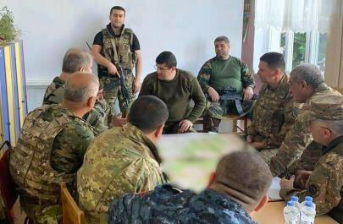

It was also revealed that the place where Harutyunyan held a "meeting" was not "the south-eastern direction of the front", but in fact the kindergarten No. 3 in Khankendi.
It should be noted that this is a method constantly used by the Armenian army. So, they choose either a house of culture, or a school, or a kindergarten as a military base. When the Azerbaijani Army strikes the area, it is rumored that Azerbaijan is firing on civilian targets. However, Azerbaijan strikes only the legitimate military facilities. They use civilian objects, as a “human shields” which is prohibited in the context of armed conflicts. This rule is set forth in the Third Geneva Convention (with respect to prisoners of war), the Fourth Geneva Convention (with respect to protected civilians) and Additional Protocol I (with respect to civilians in general).
Under the Statute of the International Criminal Court, “utilizing the presence of a civilian or other protected person to render certain points, areas or military forces immune from military operations” constitutes a war crime in international armed conflicts.
It is a clear violation of the educational rights of children which are stipulated at the articles 28 and 38 of the Child Rights Convention and also the principles stated at the Safe Schools Declaration.
According to the Article 38 of the Convention on the Rights of the Child (1989), State undertake to respect and to ensure respect for rules of international humanitarian law applicable to them in armed conflicts which are relevant to the child. State have obligations under international humanitarian law to protect the civilian population in armed conflicts, and shall take all feasible measures to ensure protection and care of children who are affected by an armed conflict.
İt should also noted that according to the Safe Schools Declaration, it is prohibited to use educational facilities as basis bases, barracks or detention centres during the armed conflict. Such actions expose students and education personnel to harm, deny large numbers of children and students their right to education and so deprive communities of the foundations on which to build their future. Where educational facilities are used for military purposes it can increase the risk of the recruitment and use of children by armed actors or may leave children and youth vulnerable to sexual abuse or exploitation. In particular, it may increase the likelihood that education institutions are attacked.
The Safe Schools Declaration is an inter-governmental political commitment that was opened for endorsement by countries at an international conference held in Oslo, Norway, on 28–29 May 2015. The Declaration provides countries the opportunity to express political support for the protection of students, teachers, and schools during times of armed conflict; the importance of the continuation of education during armed conflict; and the implementation of the Guidelines for Protecting Schools and Universities from Military Use during Armed Conflict.

International law aspects of the special protection of children

In non-international armed conflicts, children are protected by the fundamental guarantees relating to the treatment of persons taking no active part in the hostilities, set forth in article 3 common to the four Geneva Conventions. Under this article, children have at least the right, during these conflicts which are often very cruel, to be treated humanely. There should not be any violence to their lives and persons or their dignity.
The principle of the special protection of children during non- international armed conflicts is thus explicitly laid down. Protocol II of the Geneva Conventions, Article 4, entitled " Fundamental guarantees " , comprises a paragraph devoted exclusively to children. It stipulates that: "Children shall be provided with the care and aid they require " . This article then enumerates special measures relative to children, giving substance to the general rule stated above. The structure of article 4 shows how important the authors of Protocol II considered the protection of children during non-international armed conflicts, and it enables us to maintain that the principle of special protection of children during these conflicts is thereby affirmed.
The protection of children in armed conflict demands to be at the center of the global agenda. The laws, rights and norms governing the protection of civilians in conflict were drafted in response to 20th century wars that illustrate the worst of humanity. Even though international community falling short in their moral duty of protecting children adequately, in increasingly fractured world children can serve as a unifying force. Their rights and their claim on international protection transcend national borders, cultures and faiths.
As Eglantyne Jebb, the founder of Save the Children, once put it: ‘Every generation of children offers mankind the possibility of rebuilding his ruin of a world.’ If humanity cannot come together to protect children from the horror of war, what hope is there for international cooperation in other areas?

Children are protected not only by the International humanitarian law, but also by the International human rights law. According to the Article 38 of the Convention on the Rights of the Child (1989), State undertake to respect and to ensure respect for rules of international humanitarian law applicable to them in armed conflicts which are relevant to the child. State have obligations under international humanitarian law to protect the civilian population in armed conflicts, and shall take all feasible measures to ensure protection and care of children who are affected by an armed conflict.
Thus, by targeting the civilian population, the Armenian armed forces are not only committing war crimes under humanitarian law, but also grossly violating the principles and provisions of international human rights.

UNICEF statement on the Nagorno-Karabakh conflict

Recently, UNICEF is made a public statement on the conflict, by saying that, “the ongoing conflict in and beyond Nagorno-Karabakh is inflicting an appalling and unacceptable toll on children. In addition to the mounting number of child fatalities and injuries, dozens of homes and schools have been damaged or destroyed. Countless children and families have endured extreme psychological trauma and distress for weeks.
UNICEF appeals, in the strongest possible terms, for an immediate implementation of the humanitarian ceasefire which both parties agreed to on 9 October. Children, families and the civilian facilities that they depend upon must be protected, in line with international human rights and humanitarian law. A complete cessation of hostilities is in the best interest of all children”.

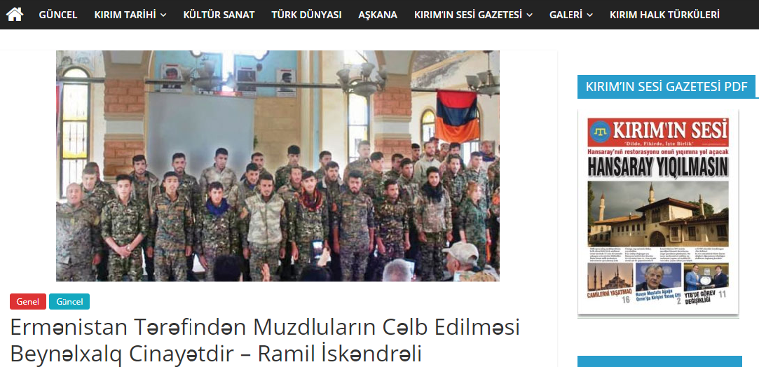
Mercenaries in Karabakh conflict in Armenian side are the threat to civilians

According to investigations conducted by the Prosecutor General's Office of the Republic of Azerbaijan, members of various terrorist organizations, including foreign nationals, have illegally crossed the state border into Armenia and established illegal armed groups. It has also been determined that they are used as mercenaries in the aggressive war aimed at occupying our territories. In the Armenian army, people from other countries are fighting as mercenaries. According to reports, Armenians from Syria, Lebanon, the United States, Canada and France are joining the Armenian army. We also have some concerns about the involvement of the PKK terrorist organization in the war.
The concept of mercenary is enshrined in Article 47 of Additional Protocol I (1977) to the 1949 Geneva Convention for the Protection of Victims of International Armed Conflict. According to this article, a mercenary has no right to receive the status of a combatant or prisoner of war.
The International Convention on the Recruitment, Use, Financing and Training of Mercenaries, adopted by the 44th session of the UN General Assembly on 4 December 1989 (44/34), , criminalizes their use and training.
Unlike Armenia, the Republic of Azerbaijan acceded to the Convention in 30 September 1997. In order to combat the involvement of mercenaries in military conflicts under the Convention, States Parties shall provide for criminal liability in national law for such offences.
According to Article 114 of the Criminal Code of the Republic of Azerbaijan, it is a crime to recruit, train, finance and provide other material support to mercenaries, as well as to use them in a military conflict or military operation.
Even Article 395 of the Criminal Code of Armenia criminalizes the involvement of mercenaries. Pursuant to Article 15 (2) of the International Covenant on Civil and Political Rights, adopted in 1966, “any act or omission committed by any person which is a crime in accordance with the principles of law accepted by the international community shall be prosecuted. It does not prevent him from being extradited and punished.”
The UN General Assembly's Declaration on the Principles of International Law on Friendship and Cooperation between States, 1970, prohibits UN member states from engaging in mercenary conflicts. Apparently, mercenaries are recognized as criminals under international law and must be brought to justice as international criminals. Universal jurisdiction has been established in accordance with the principle of "aut dedere aut judiciare" (obligation to prosecute). At the same time involement of mercenaries under the customary norms of international humanitarian law, is prohibited.
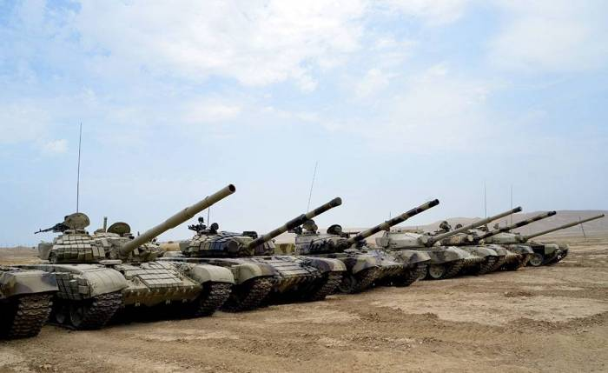
Involement of mercenaries is generally a human problem. The social danger of mercenaries lies not only in the fact that mercenaries commit murder, robbery, violence and other crimes, but also the development of a profession of murder and other crimes. Armenia is once again violating the norms of international law by actively involving mercenaries against Azerbaijan

How to protect civilians?

Peace enforcement operations (PEOps) by Azerbaijan to protect civilians

The key question is, how to stop Armenian attacks on civilians in Azerbaijan?

The Aide to the President of the Republic of Azerbaijan Hikmet Hajiyev in its briefing for diplomatic corps representatives, in September 28, 2020, said that “The Armed Forces of the Republic of Azerbaijan operate in the sovereign territories of the Republic of Azerbaijan and organize the defense of Azerbaijan. These are defensive operations. Here, too, the main goal is to ensure the security of the Azerbaijani civilian population living close to the line of contact and to implement counter-offensive measures to prevent such provocations by Armenia. These operations can even be called Peace Enforcement. In this way, Armenia will finally be forced to make peace and participate constructively in the negotiation process. "

If we turn to international law, we will see that operations by Azerbaijani forces to stop Armenian occupation of Karabakh region of Azerbaijan and force Armenia for peace are completely legitimate from the point of view of international law.

Azerbaijan has an inherent right of self-defense against Armenia’s aggression—including the right to organize its self-defense collectively and implement Peace Enforcement Operations in its own territory that occupied by Armenia. By no means does international law impede other States from assisting Azerbaijan. To the contrary, international law envisages it. In December 2010, both countries signed a Treaty that makes each other a guarantor in case of an attack by foreign forces.
Second, the territory of occupied Karabakh region is the territory within the borders of Azerbaijan that every state in the world has recognized.
What is the Peace Enforcement operation (PEOps) according to the international law? PEOps are forcible military interventions by one or more states into a third country with the express objective of maintaining or restoring international, regional or local peace and security by ending a violent conflict.

The formal legal basis for PEOps is under Chapter VII of the United Nations Charter. Thus, in accordance with the provisions of Chapter VII of the UN Charter, as a rule, with the use of elements of coercive action, in order to prevent aggression or threats to international peace and security by any state, or by the parties to the conflict or the state in conflict. These are peace enforcement operations carried out by the without the consent of the international community. These operations can be carried out only on the basis of a UN Security Council resolution. As we know, 4 UN Security Council resolutions have been adopted on the settlement of the Nagorno-Karabakh conflict.

The resolutions noted that stability and peace in the region were under threat, expressed concern over the growing number of IDPs and stressed the need to address the problems caused by the state of emergency in the occupied territories. The UN Security Council called for an end to the occupation in order to achieve a permanent ceasefire and the withdrawal of the Armenian forces from the occupied territories of Azerbaijan. At present, Azerbaijan is exercising the right to self-defense enshrined in Article 51 of the UN Charter within the framework of these resolutions, as well as the use peace enforcement operations provided for in Chapter VII of the UN Charter.

According to the Paragraph 138 of the Resolution on the Outcomes of the World Summit, adopted by the UN General Assembly on 16 September 2005, at the World Summit of the Heads of State and Government, have gathered at United Nations Headquarters in New York from 14 to 16 September 2005, the Heads of States reaffirmed that each individual State has the responsibility to protect its populations from genocide, war crimes, ethnic cleansing and crimes against humanity. This responsibility entails the prevention of such crimes, including their incitement, through appropriate and necessary means. Azerbaijan is acting in accordance with it. The international community should, as appropriate, encourage and help States to exercise this responsibility. The international community, through the United Nations, also has the responsibility to use appropriate diplomatic, humanitarian and other peaceful means, in accordance with Chapters VI and VIII of the UN Charter, to help to protect populations from genocide, war crimes, ethnic cleansing and crimes against humanity.

In international practice, the doctrine of peace enforcement has been used in several cases. For example, the principle of peace enforcement was applied in Bosnia-Herzegovina under the 1995 Dayton Agreement. At that time, the country was effectively divided into the "Serbian Republic" and the Muslim-Croatian Federation of Bosnia and Herzegovina, and there was a conflict between them. But in the end, as a result of peace enforcement measures, the separatist regime of the "Serbian Republic" which was created within Bosnia and Herzegovina was forced into peace and the conflict was resolved.

Another example is the Ulster conflict between the British and the Irish, where there has been a confrontation between Catholics and Protestants loyal to England since the early twentieth century, demanding the annexation of the territory to the Republic of Ireland. As a result of peace enforcement measures, the area is currently not annexed to Ireland. The concept of peace enforcement has been applied by in the context of the UN Charter and the UN peacekeeping doctrine during various periods of armed conflicts in African countries.

Immediately after Iraq's military intervention in Kuwait on August 2, 1990, sanctions were imposed on the country by a UN Security Council resolution, which began to be implemented and lasted until 2003. As sanctions continued, the Iraqi government was forced to step back over disputed territories with Kuwait. We can cite the precedents of Cambodia, East Timor, Rwanda, Somalia and Yugoslavia for the immediate implementation of UN Security Council resolutions and the immediate implementation of peace enforcement mechanisms.

Finally, I have to say that, it is easy to start a war, but very difficult to end it. The peace process is always complicated and almost never leads to a full settlement of the conflict. Peace enforcement operations are important for a completely fair settlement of the conflict.

Conclusion and appeal to international community

We call on international organizations to take serious steps against Armenia, which hypocritically violated the ceasefire and killed many innocent children and women, and stop the aggressor. The international organizations responsible for the protection of peace and security in the world, the protection of human rights and freedoms, the observance of the norms and principles of international law, the implementation of international conventions prohibiting the killing of civilians, cannot ignore the fact that Armenia is blatantly and grossly waging war against Armenia in front of the whole world. Indifference attitude of international organizations to this aggression against Azerbaijan will be assessed as open disrespect for human values, international law and international humanitarian law.
We hope that international organizations will strongly condemn these crimes against humanity committed by Armenia and take necessary measures to sanction the aggressor.

Ramil Iskandarli

Chairman of the “Legal Analysis and Research” Public Union,
Professional doctoral degree student, “Security and Community Safety”,
London Metropolitan University,
Master of Law, “International Humanitarian Law and Human Rights Law”, European Viadrina University.

Contributions to the report were made by Rashid Mammadov, Subhan Talibli, Ramil Mammadli, Ismayil Karimov, Kamala Ashumova, Nigar Iskandarova and Elmari Mamishov.

@Legal Analysis and Research Public Union, 2020. http://Laied.az

